Much prefer the enter key to the [X]

Suggested script change:
CAPTION 1
Hi Cicero it’s so great of you to let me look at your work for possible selection for our new show at MoMA. I think your paintings are so powerful, they really stand out and make people feel something.
CAPTION 2
The stuff here in the studio is terrific but what I need from you is some new work specifically made for the show. We’re looking etc….
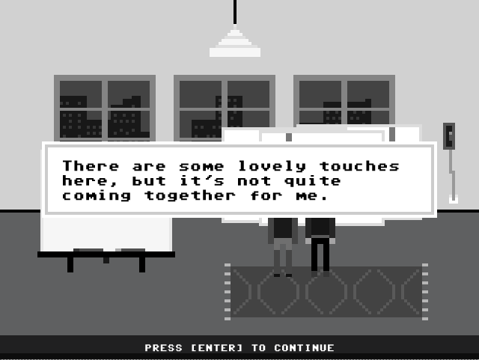
Once again the curator seems to have a very limited idea of what a great painting is. But no one said it was going to be easy, so back to the studio.
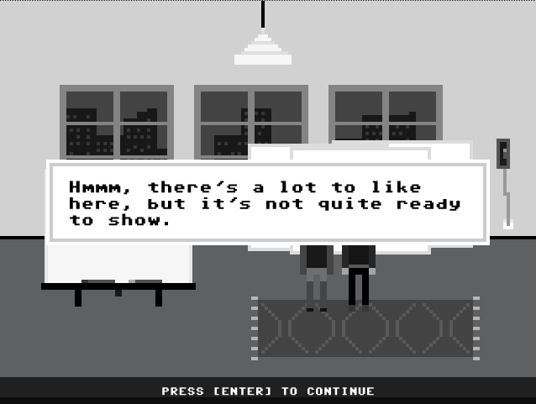
WHAT! How about ‘Troutfield’? Huh.
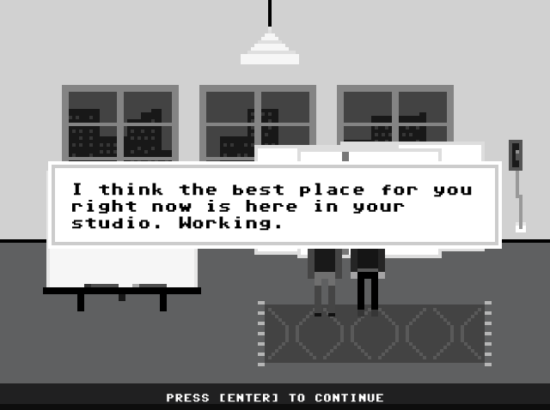
And I think the best place for you is … ah forget it, I’ll do a couple more. Curator, can’t live with them, can’t live without them.
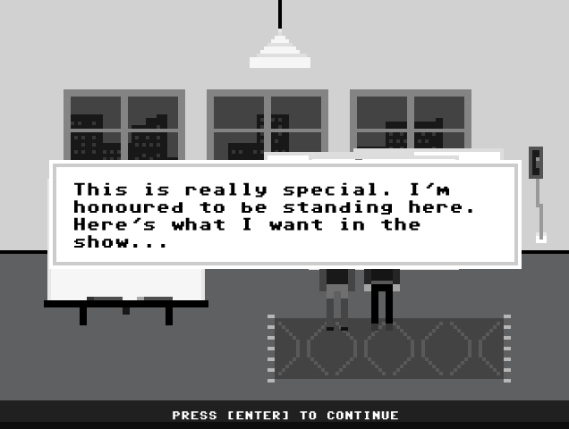
As I thought. Just change the titles and you change the ATTITUDE.

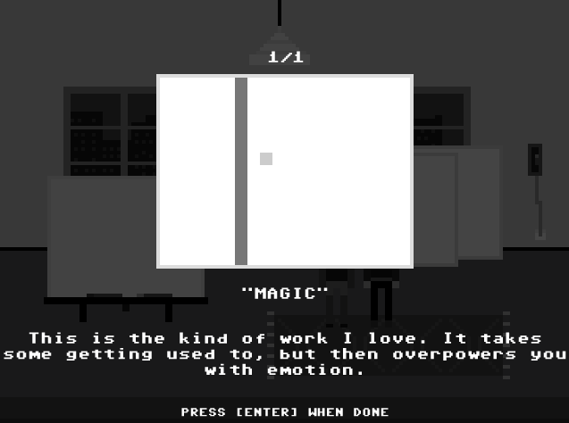
Better believe it…hmmmm. Don’t like the look of that 1/1 up there…
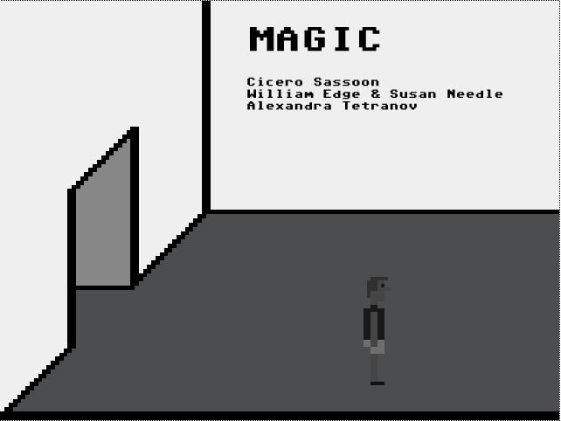
I think having the painting title feels wrong. You would expect it to be the name of the show with the artist’s names below as they are. Something like:
SYNAPSIS
the contemporary moment

… or something like that
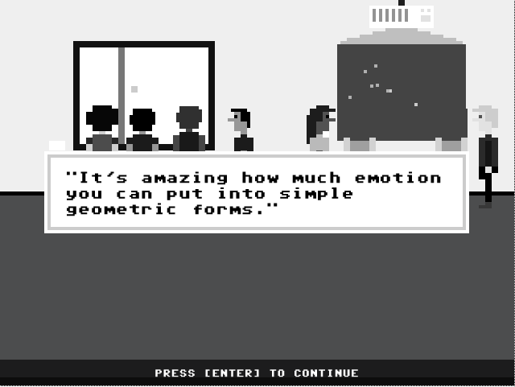
The audience totally gets my work. So why only one in the show?
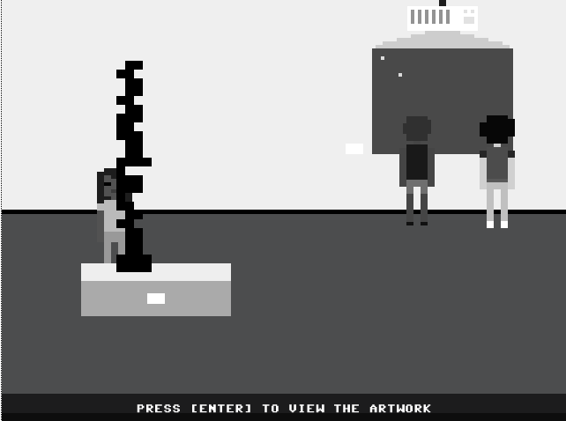
Sculpture, sculpture, sculpture. Performance, performance, performance. WHAT ABOUT MORE DAMN PAINTING!
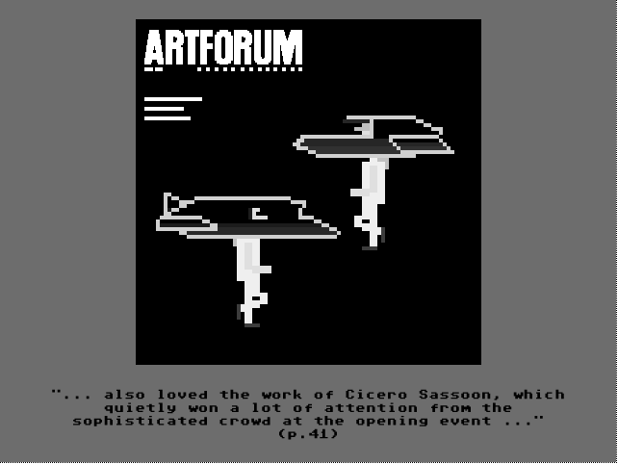
But…but…how come my PAINTING wasn’t on the cover????? That performance work is completely lame.
This is great. Works like a charm and so much easier to get around and do stuff. Loved the people talking about the work. Well done. Another great game. Ignore Sassoon, he’s completely up himself, if you ask me he was lucky to get into the show at all.

